Jenkins CI/CD Pipeline for Flask Application
Jenkins CI/CD Pipeline for Flask Application
Name: Saranya S ID: 13487
Date: 04th July 2026

Step 1: Fork GitHub Repository and clone.
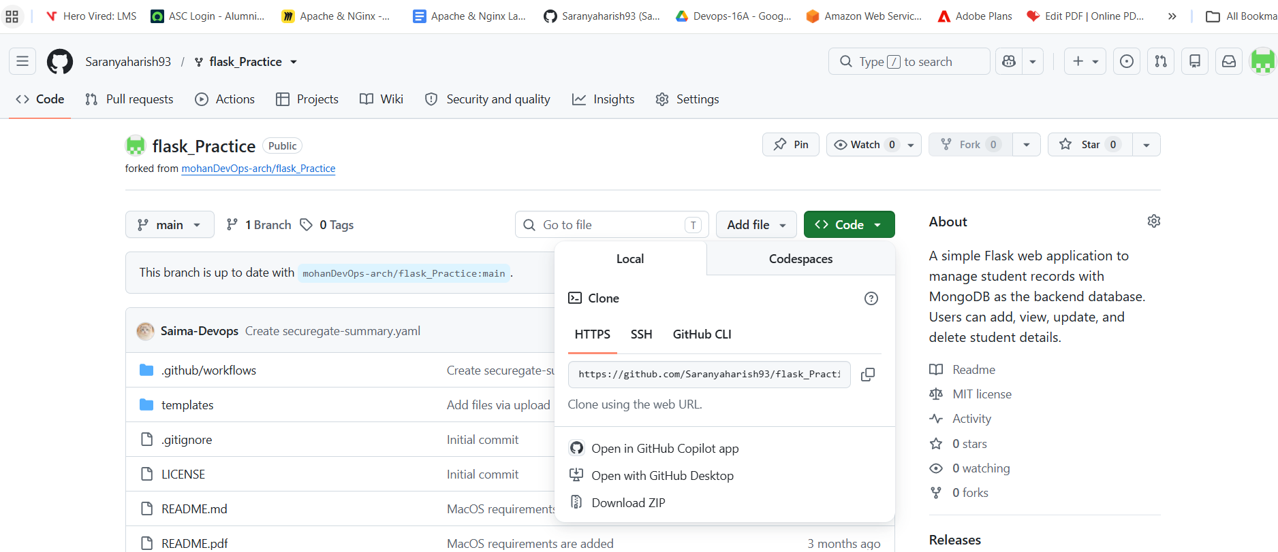
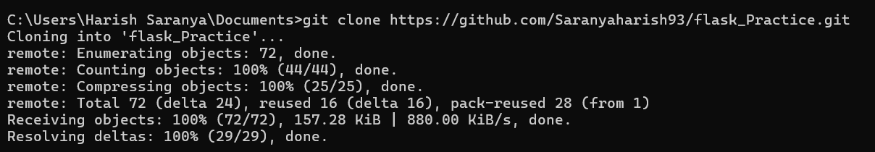
Step 2: Create Jenkinsfile
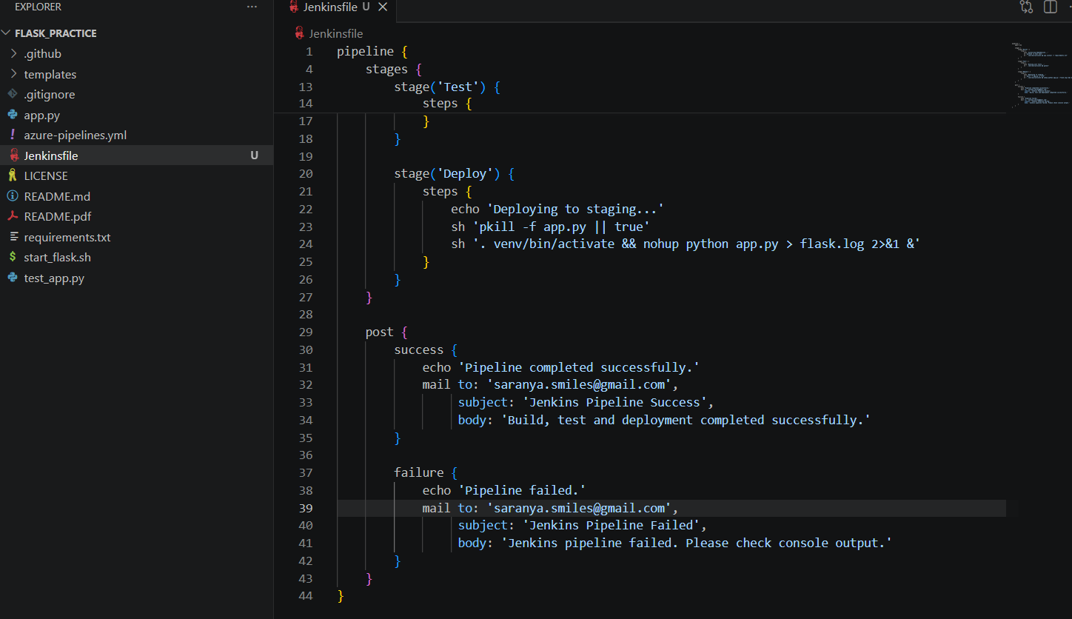

Step 3: Install Jenkins Plugins
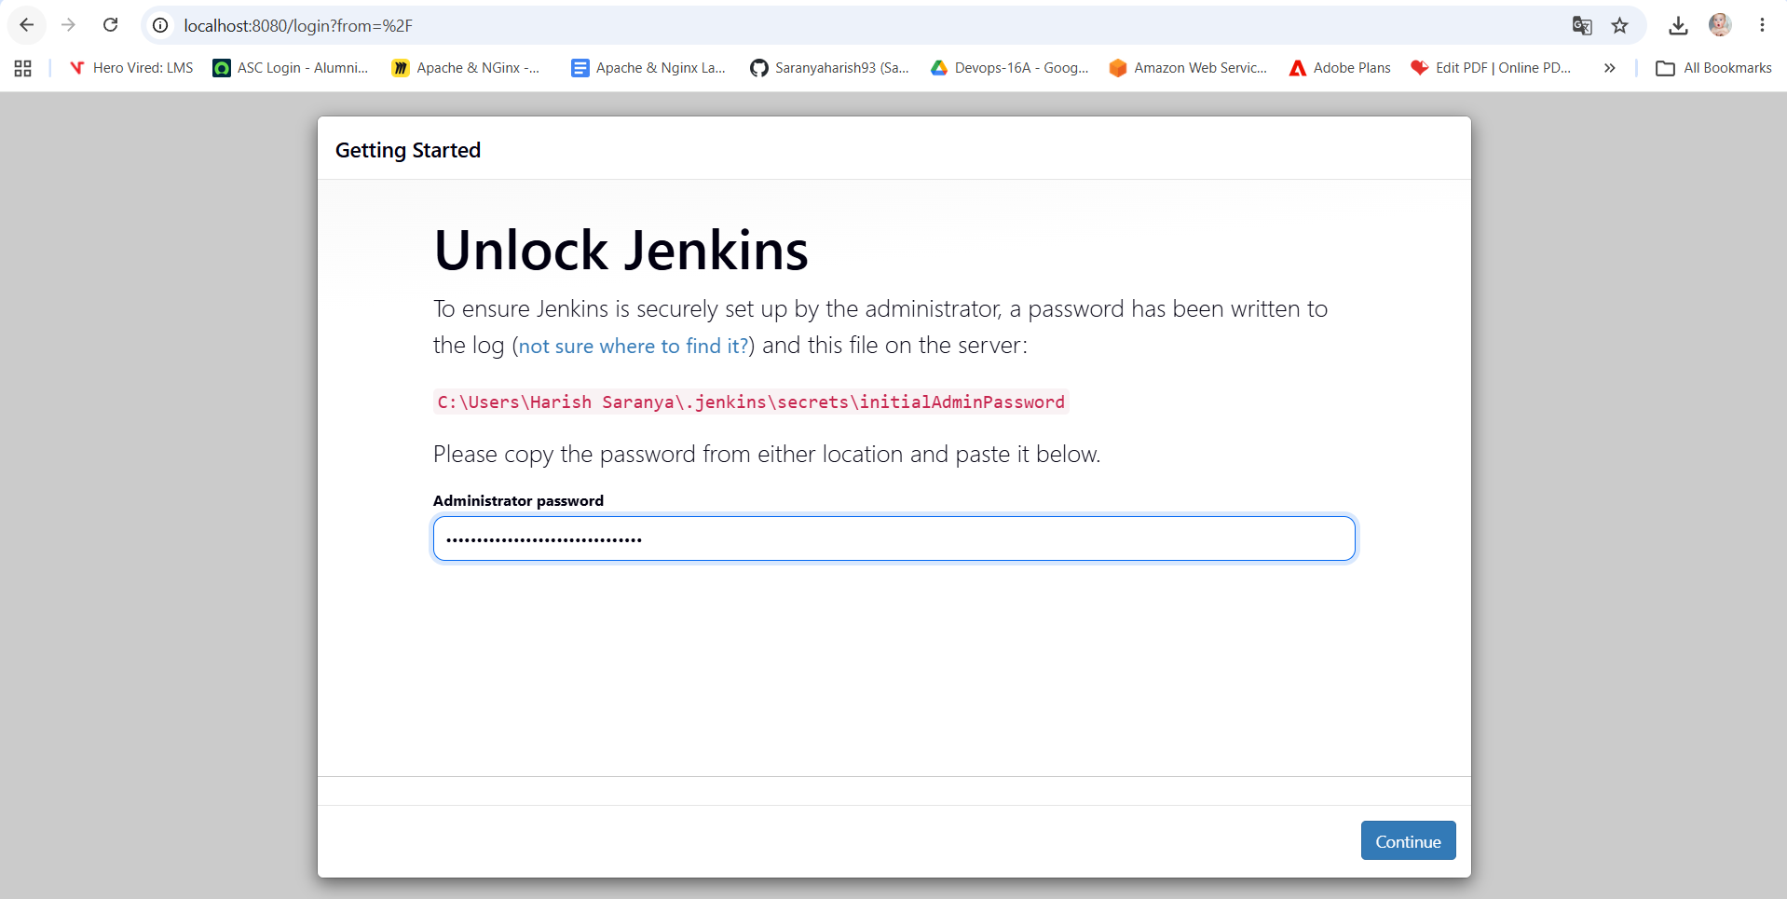

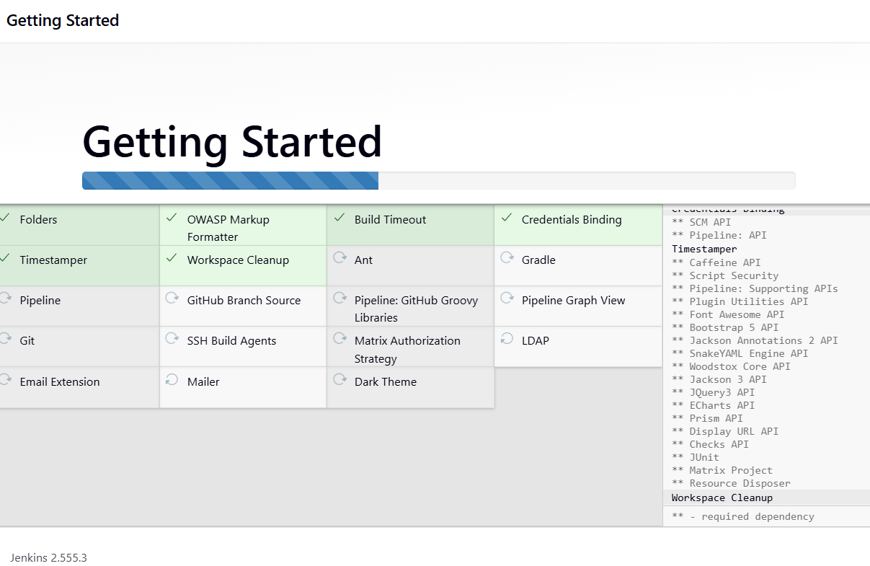

Step 4: Configure Python in Jenkins Server
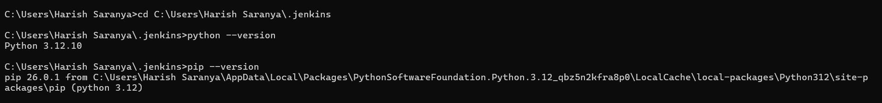
C:\Users\Harish Saranya\Documents\flask_Practice>pip install -r requirements.txt
Defaulting to user installation because normal site-packages is not writeable
Requirement already satisfied: Flask in C:\Users\Harish Saranya\AppData\Local\Packages\PythonSoftwareFoundation.Python.3.12_qbz5n2kfra8p0\LocalCache\local-packages\Python312\site-packages (from -r requirements.txt (line 1)) (3.1.2)
Requirement already satisfied: Flask-PyMongo in C:\Users\Harish Saranya\AppData\Local\Packages\PythonSoftwareFoundation.Python.3.12_qbz5n2kfra8p0\LocalCache\local-packages\Python312\site-packages (from -r requirements.txt (line 2)) (3.0.1)
Requirement already satisfied: python-dotenv in C:\Users\Harish Saranya\AppData\Local\Packages\PythonSoftwareFoundation.Python.3.12_qbz5n2kfra8p0\LocalCache\local-packages\Python312\site-packages (from -r requirements.txt (line 3)) (1.2.1)
Requirement already satisfied: pymongo in C:\Users\Harish Saranya\AppData\Local\Packages\PythonSoftwareFoundation.Python.3.12_qbz5n2kfra8p0\LocalCache\local-packages\Python312\site-packages (from -r requirements.txt (line 4)) (4.16.0)
Requirement already satisfied: certifi in C:\Users\Harish Saranya\AppData\Local\Packages\PythonSoftwareFoundation.Python.3.12_qbz5n2kfra8p0\LocalCache\local-packages\Python312\site-packages (from -r requirements.txt (line 5)) (2024.6.2)
Requirement already satisfied: pytest in C:\Users\Harish Saranya\AppData\Local\Packages\PythonSoftwareFoundation.Python.3.12_qbz5n2kfra8p0\LocalCache\local-packages\Python312\site-packages (from -r requirements.txt (line 6)) (9.0.2)
Requirement already satisfied: pylint in C:\Users\Harish Saranya\AppData\Local\Packages\PythonSoftwareFoundation.Python.3.12_qbz5n2kfra8p0\LocalCache\local-packages\Python312\site-packages (from -r requirements.txt (line 7)) (4.0.4)
Requirement already satisfied: bandit in C:\Users\Harish Saranya\AppData\Local\Packages\PythonSoftwareFoundation.Python.3.12_qbz5n2kfra8p0\LocalCache\local-packages\Python312\site-packages (from -r requirements.txt (line 8)) (1.9.3)
Requirement already satisfied: black in C:\Users\Harish Saranya\AppData\Local\Packages\PythonSoftwareFoundation.Python.3.12_qbz5n2kfra8p0\LocalCache\local-packages\Python312\site-packages (from -r requirements.txt (line 9)) (26.1.0)
Requirement already satisfied: blinker>=1.9.0 in C:\Users\Harish Saranya\AppData\Local\Packages\PythonSoftwareFoundation.Python.3.12_qbz5n2kfra8p0\LocalCache\local-packages\Python312\site-packages (from Flask->-r requirements.txt (line 1)) (1.9.0)
Requirement already satisfied: click>=8.1.3 in C:\Users\Harish Saranya\AppData\Local\Packages\PythonSoftwareFoundation.Python.3.12_qbz5n2kfra8p0\LocalCache\local-packages\Python312\site-packages (from Flask->-r requirements.txt (line 1)) (8.3.1)
Requirement already satisfied: itsdangerous>=2.2.0 in C:\Users\Harish Saranya\AppData\Local\Packages\PythonSoftwareFoundation.Python.3.12_qbz5n2kfra8p0\LocalCache\local-packages\Python312\site-packages (from Flask->-r requirements.txt (line 1)) (2.2.0)
Requirement already satisfied: jinja2>=3.1.2 in C:\Users\Harish Saranya\AppData\Local\Packages\PythonSoftwareFoundation.Python.3.12_qbz5n2kfra8p0\LocalCache\local-packages\Python312\site-packages (from Flask->-r requirements.txt (line 1)) (3.1.4)
Requirement already satisfied: markupsafe>=2.1.1 in C:\Users\Harish Saranya\AppData\Local\Packages\PythonSoftwareFoundation.Python.3.12_qbz5n2kfra8p0\LocalCache\local-packages\Python312\site-packages (from Flask->-r requirements.txt (line 1)) (2.1.5)
Requirement already satisfied: werkzeug>=3.1.0 in C:\Users\Harish Saranya\AppData\Local\Packages\PythonSoftwareFoundation.Python.3.12_qbz5n2kfra8p0\LocalCache\local-packages\Python312\site-packages (from Flask->-r requirements.txt (line 1)) (3.1.5)
Requirement already satisfied: dnspython<3.0.0,>=2.6.1 in C:\Users\Harish Saranya\AppData\Local\Packages\PythonSoftwareFoundation.Python.3.12_qbz5n2kfra8p0\LocalCache\local-packages\Python312\site-packages (from pymongo->-r requirements.txt (line 4)) (2.8.0)
Requirement already satisfied: colorama>=0.4 in C:\Users\Harish Saranya\AppData\Local\Packages\PythonSoftwareFoundation.Python.3.12_qbz5n2kfra8p0\LocalCache\local-packages\Python312\site-packages (from pytest->-r requirements.txt (line 6)) (0.4.6)
Requirement already satisfied: iniconfig>=1.0.1 in C:\Users\Harish Saranya\AppData\Local\Packages\PythonSoftwareFoundation.Python.3.12_qbz5n2kfra8p0\LocalCache\local-packages\Python312\site-packages (from pytest->-r requirements.txt (line 6)) (2.3.0)
Requirement already satisfied: packaging>=22 in C:\Users\Harish Saranya\AppData\Local\Packages\PythonSoftwareFoundation.Python.3.12_qbz5n2kfra8p0\LocalCache\local-packages\Python312\site-packages (from pytest->-r requirements.txt (line 6)) (24.1)
Requirement already satisfied: pluggy<2,>=1.5 in C:\Users\Harish Saranya\AppData\Local\Packages\PythonSoftwareFoundation.Python.3.12_qbz5n2kfra8p0\LocalCache\local-packages\Python312\site-packages (from pytest->-r requirements.txt (line 6)) (1.6.0)
Requirement already satisfied: pygments>=2.7.2 in C:\Users\Harish Saranya\AppData\Local\Packages\PythonSoftwareFoundation.Python.3.12_qbz5n2kfra8p0\LocalCache\local-packages\Python312\site-packages (from pytest->-r requirements.txt (line 6)) (2.18.0)
Requirement already satisfied: astroid<=4.1.dev0,>=4.0.2 in C:\Users\Harish Saranya\AppData\Local\Packages\PythonSoftwareFoundation.Python.3.12_qbz5n2kfra8p0\LocalCache\local-packages\Python312\site-packages (from pylint->-r requirements.txt (line 7)) (4.0.3)
Requirement already satisfied: dill>=0.3.6 in C:\Users\Harish Saranya\AppData\Local\Packages\PythonSoftwareFoundation.Python.3.12_qbz5n2kfra8p0\LocalCache\local-packages\Python312\site-packages (from pylint->-r requirements.txt (line 7)) (0.4.1)
Requirement already satisfied: isort!=5.13,<8,>=5 in C:\Users\Harish Saranya\AppData\Local\Packages\PythonSoftwareFoundation.Python.3.12_qbz5n2kfra8p0\LocalCache\local-packages\Python312\site-packages (from pylint->-r requirements.txt (line 7)) (7.0.0)
Requirement already satisfied: mccabe<0.8,>=0.6 in C:\Users\Harish Saranya\AppData\Local\Packages\PythonSoftwareFoundation.Python.3.12_qbz5n2kfra8p0\LocalCache\local-packages\Python312\site-packages (from pylint->-r requirements.txt (line 7)) (0.7.0)
Requirement already satisfied: platformdirs>=2.2 in C:\Users\Harish Saranya\AppData\Local\Packages\PythonSoftwareFoundation.Python.3.12_qbz5n2kfra8p0\LocalCache\local-packages\Python312\site-packages (from pylint->-r requirements.txt (line 7)) (4.2.2)
Requirement already satisfied: tomlkit>=0.10.1 in C:\Users\Harish Saranya\AppData\Local\Packages\PythonSoftwareFoundation.Python.3.12_qbz5n2kfra8p0\LocalCache\local-packages\Python312\site-packages (from pylint->-r requirements.txt (line 7)) (0.14.0)
Requirement already satisfied: PyYAML>=5.3.1 in C:\Users\Harish Saranya\AppData\Local\Packages\PythonSoftwareFoundation.Python.3.12_qbz5n2kfra8p0\LocalCache\local-packages\Python312\site-packages (from bandit->-r requirements.txt (line 8)) (6.0.1)
Requirement already satisfied: stevedore>=1.20.0 in C:\Users\Harish Saranya\AppData\Local\Packages\PythonSoftwareFoundation.Python.3.12_qbz5n2kfra8p0\LocalCache\local-packages\Python312\site-packages (from bandit->-r requirements.txt (line 8)) (5.2.0)
Requirement already satisfied: rich in C:\Users\Harish Saranya\AppData\Local\Packages\PythonSoftwareFoundation.Python.3.12_qbz5n2kfra8p0\LocalCache\local-packages\Python312\site-packages (from bandit->-r requirements.txt (line 8)) (14.3.2)
Requirement already satisfied: mypy-extensions>=0.4.3 in C:\Users\Harish Saranya\AppData\Local\Packages\PythonSoftwareFoundation.Python.3.12_qbz5n2kfra8p0\LocalCache\local-packages\Python312\site-packages (from black->-r requirements.txt (line 9)) (1.1.0)
Requirement already satisfied: pathspec>=1.0.0 in C:\Users\Harish Saranya\AppData\Local\Packages\PythonSoftwareFoundation.Python.3.12_qbz5n2kfra8p0\LocalCache\local-packages\Python312\site-packages (from black->-r requirements.txt (line 9)) (1.0.4)
Requirement already satisfied: pytokens>=0.3.0 in C:\Users\Harish Saranya\AppData\Local\Packages\PythonSoftwareFoundation.Python.3.12_qbz5n2kfra8p0\LocalCache\local-packages\Python312\site-packages (from black->-r requirements.txt (line 9)) (0.4.1)
Requirement already satisfied: pbr!=2.1.0,>=2.0.0 in C:\Users\Harish Saranya\AppData\Local\Packages\PythonSoftwareFoundation.Python.3.12_qbz5n2kfra8p0\LocalCache\local-packages\Python312\site-packages (from stevedore>=1.20.0->bandit->-r requirements.txt (line 8)) (6.0.0)
Requirement already satisfied: markdown-it-py>=2.2.0 in C:\Users\Harish Saranya\AppData\Local\Packages\PythonSoftwareFoundation.Python.3.12_qbz5n2kfra8p0\LocalCache\local-packages\Python312\site-packages (from rich->bandit->-r requirements.txt (line 8)) (4.0.0)
Requirement already satisfied: mdurl~=0.1 in C:\Users\Harish Saranya\AppData\Local\Packages\PythonSoftwareFoundation.Python.3.12_qbz5n2kfra8p0\LocalCache\local-packages\Python312\site-packages (from markdown-it-py>=2.2.0->rich->bandit->-r requirements.txt (line 8)) (0.1.2)

[notice] A new release of pip is available: 26.0.1 -> 26.1.2
[notice] To update, run: C:\Users\Harish Saranya\AppData\Local\Microsoft\WindowsApps\PythonSoftwareFoundation.Python.3.12_qbz5n2kfra8p0\python.exe -m pip install --upgrade pip

C:\Users\Harish Saranya\Documents\flask_Practice>pip install pytest
Defaulting to user installation because normal site-packages is not writeable
Requirement already satisfied: pytest in C:\Users\Harish Saranya\AppData\Local\Packages\PythonSoftwareFoundation.Python.3.12_qbz5n2kfra8p0\LocalCache\local-packages\Python312\site-packages (9.0.2)
Requirement already satisfied: colorama>=0.4 in C:\Users\Harish Saranya\AppData\Local\Packages\PythonSoftwareFoundation.Python.3.12_qbz5n2kfra8p0\LocalCache\local-packages\Python312\site-packages (from pytest) (0.4.6)
Requirement already satisfied: iniconfig>=1.0.1 in C:\Users\Harish Saranya\AppData\Local\Packages\PythonSoftwareFoundation.Python.3.12_qbz5n2kfra8p0\LocalCache\local-packages\Python312\site-packages (from pytest) (2.3.0)
Requirement already satisfied: packaging>=22 in C:\Users\Harish Saranya\AppData\Local\Packages\PythonSoftwareFoundation.Python.3.12_qbz5n2kfra8p0\LocalCache\local-packages\Python312\site-packages (from pytest) (24.1)
Requirement already satisfied: pluggy<2,>=1.5 in C:\Users\Harish Saranya\AppData\Local\Packages\PythonSoftwareFoundation.Python.3.12_qbz5n2kfra8p0\LocalCache\local-packages\Python312\site-packages (from pytest) (1.6.0)
Requirement already satisfied: pygments>=2.7.2 in C:\Users\Harish Saranya\AppData\Local\Packages\PythonSoftwareFoundation.Python.3.12_qbz5n2kfra8p0\LocalCache\local-packages\Python312\site-packages (from pytest) (2.18.0)

[notice] A new release of pip is available: 26.0.1 -> 26.1.2
[notice] To update, run: C:\Users\Harish Saranya\AppData\Local\Microsoft\WindowsApps\PythonSoftwareFoundation.Python.3.12_qbz5n2kfra8p0\python.exe -m pip install --upgrade pip
Step 5: Configure Jenkins Email Notification
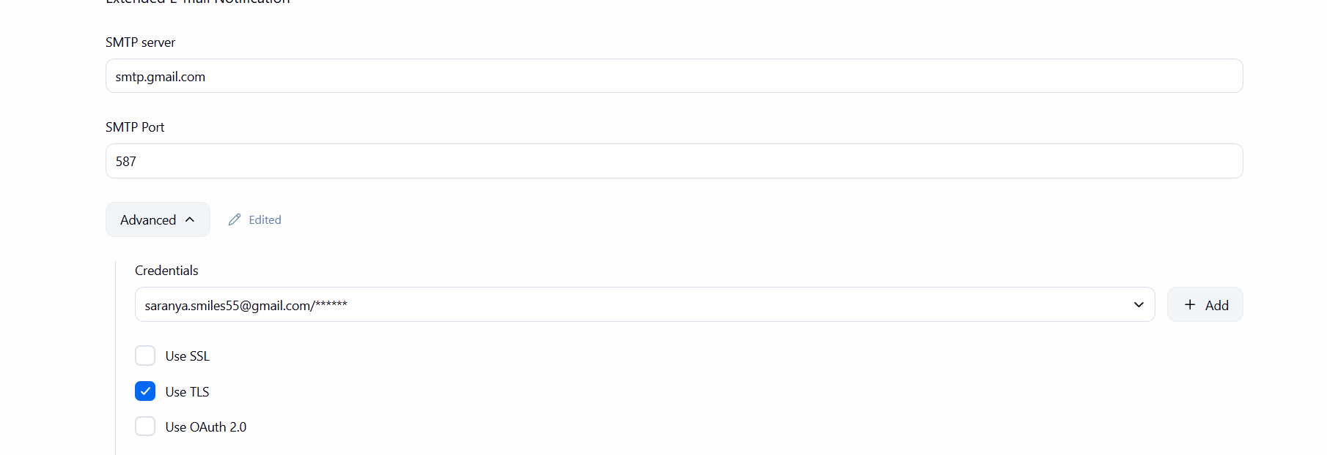
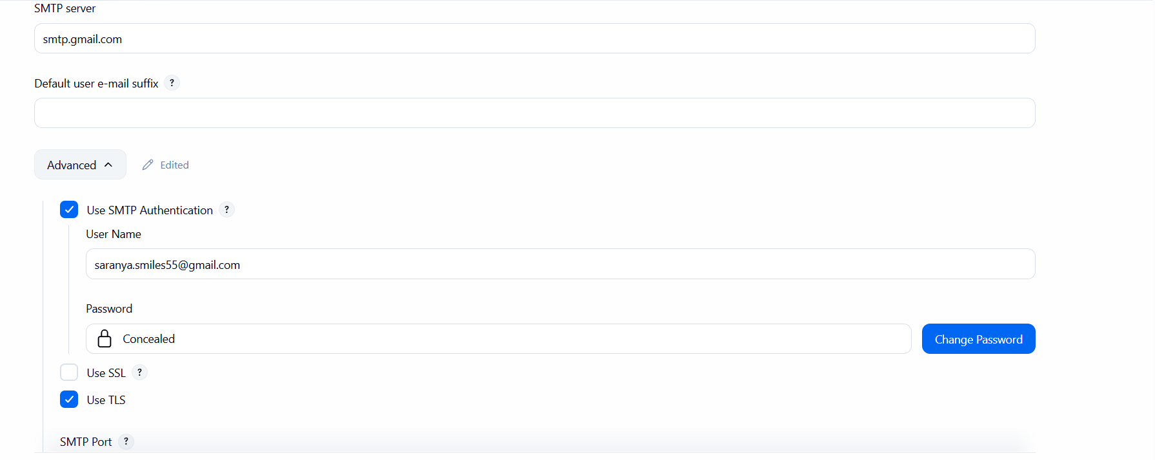
Step 6: Create Jenkins Pipeline Job

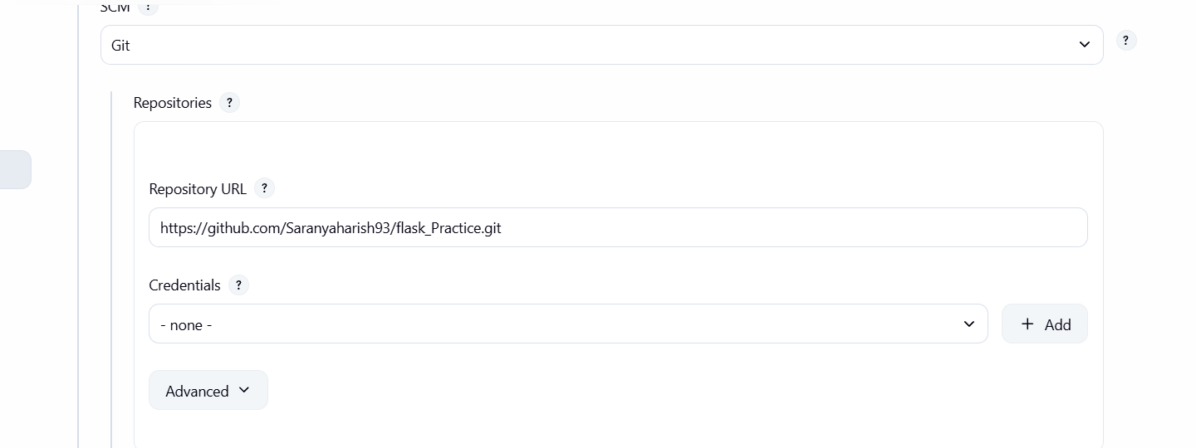
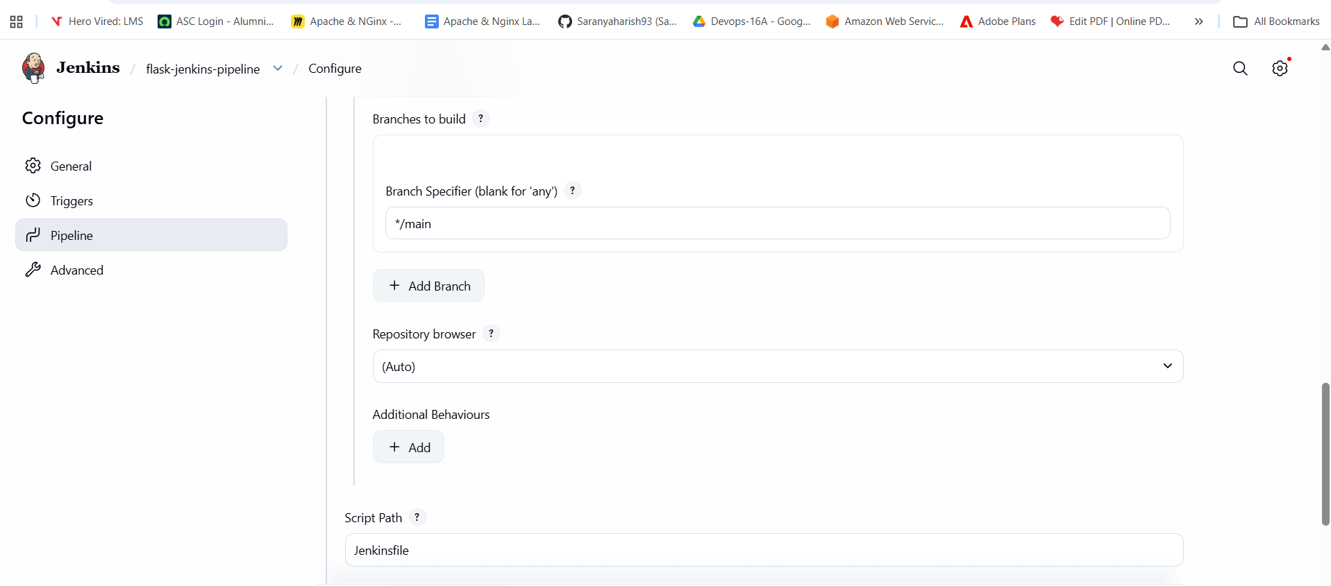

Step 7: Done changes and pushed to github
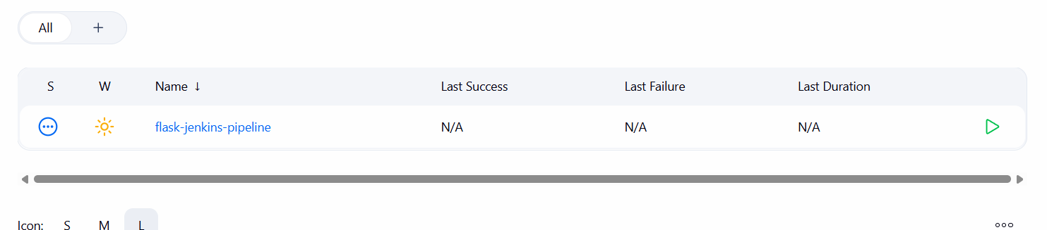

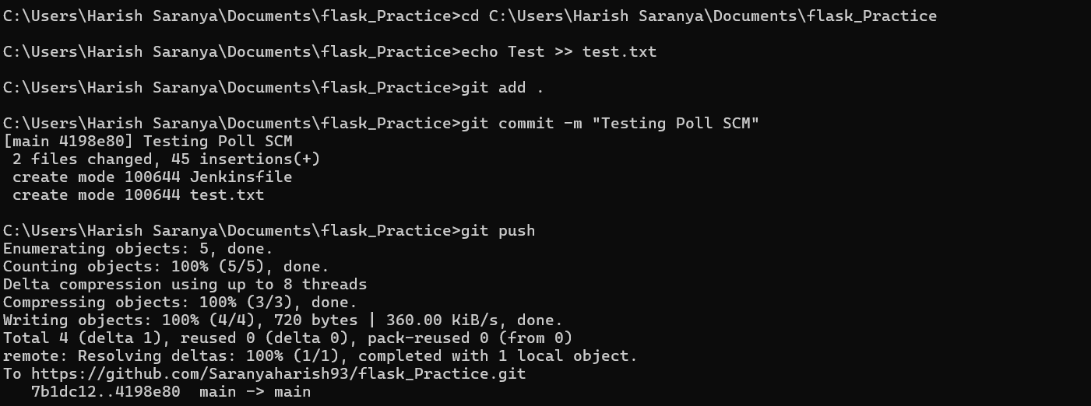
Step 8: Push Jenkinsfile to GitHub
